Hello. My name is Karter Wong, and I will present my research project on developing a CAM system for incremental forming from 3D CAD data.
I will first introduce the topic, show my progress, and discuss the next steps for next semester.
As I mentioned at the beginning of the presentation, my research topic is the development of CAM systems for incremental forming from 3D CAD data. My research project is based on Mitsumori Senpai’s research paper, which showcased a CAM system modeling and machining a truncated cone by converting STL data into G-code. My goal for this project is to make a CAM system that could model a bit more complex shapes, and the test shape I used was a dome with a square base as you will see later.
The CAM system from Mitsumori Senpai’s research can be broken into four simple steps: 1, taking the STL data from the STL file from the modeling software of your choice. 2, convert that data to a point cloud, which is all the corners of the triangles from the STL data. 3, sort the points by contour lines and nearest points or the Z coordinate. And 4, convert the sorted points into G-code.
This semester, I further developed this program to have a few more steps—and more defined sections.
My code starts by also taking the STL data and converting it to a point cloud; it identifies the variables that you set, like the number of layers you want your shape to have or the tolerance on how big the distance between the layers should be, which is represented by the program start section. Next, the program starts calculating the toolpath by using the Traveling salesperson method, essentially ensuring that the toolpath always moves to the closest point on the layer and then sorts those points so that the toolpath moves in a clockwise direction, ensuring a smooth toolpath. Then, it detects if a layer is circular or noncircular and determines which method to use to process the points.
After the program generates a tool path, it converts it to G-code and adds the general parameters for G-code, such as Absolute positioning (G90) and end program (M30).
The following functions allow the Toolpath to generate shapes like the ones you see here: rounding, TSP, Convexhull, and adjustable variables. These features are essential to the clear that you see at the top right corner. The rounding groups the layers to the nearest number you wish and eliminates redundant points. The TSP ensures that all the points on a layer are “reached” in order. Convexhull ensures that the outermost points are the only points used in the generation of the tool path, and adjustable variables ensure that you can apply this to any shape you want.
Next semester, I aim to start conducting experiments to see if making these shapes is possible. After that, I aim to find ways to improve the strength of the shape that is produced. My goal for my final presentation for my graduation thesis is to produce a more complex-looking shape, like this one.
Here are my references.
Any questions?

Notes:
- CFRTP: Carbon fiber reinforced thermo plastics
- Discontinuous fibers: are related to the orientation of the plastic in the material, the direction is random for discontinuous fibers
- Header:
  - "G90 ; (Absolute positioning)",
  - "G21 ; (Set units to millimeters)",
  - "G92 X0.0 Y0.0 Z0 ; (Set workplace origin)",
  - "F1000 ; (Set feedrate)",
  - "G01 X0.0 Y0.0 Z20 ; (Setting ensuring that the tool will move down to the work area)"
- Footer:
  - "G01 Z20 ; (Move straight up to the origin height)",
  - "M30 ; (End of program)"
- Tool path generation: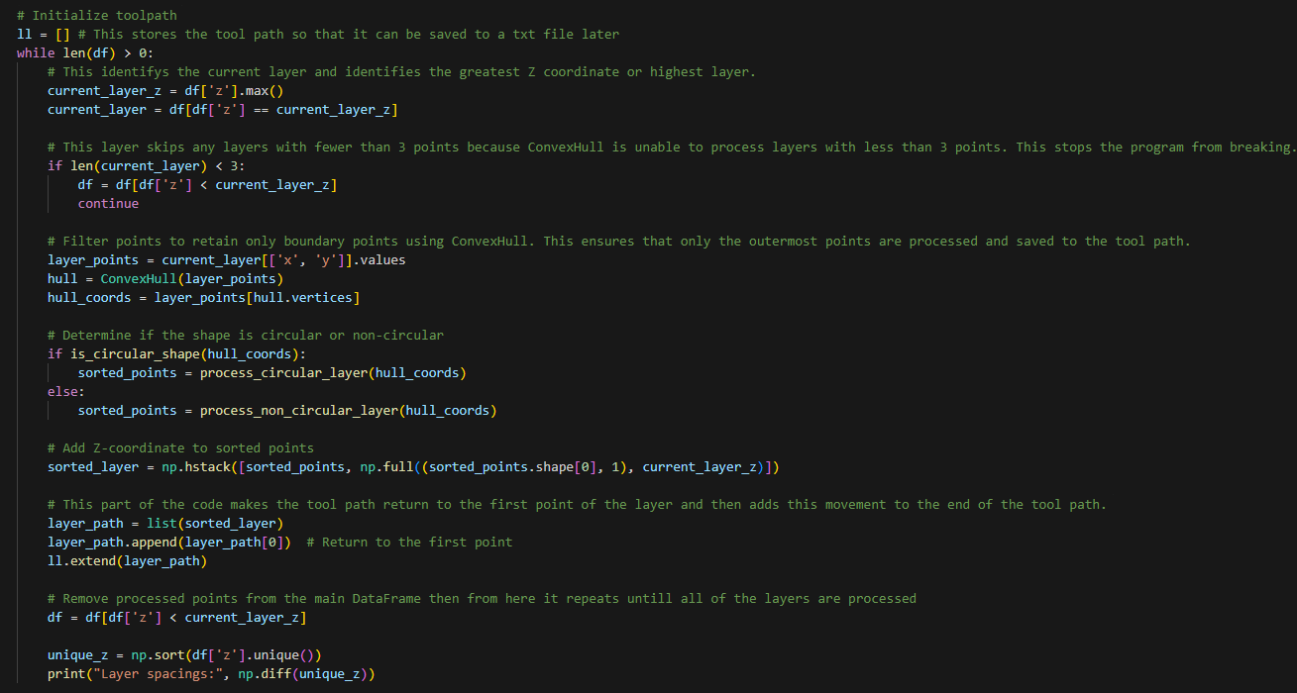
1. Initialization
- Variable ll:
  - This is an empty list that will store the toolpath as a sequence of 3D points (x, y, z).
- Purpose:
  - Each loop iteration processes one layer of the 3D model and appends its toolpath to ll.

2. Layer Processing (While Loop)
The loop continues until all layers in the dataset (df) are processed.
Step 2.1: Identify the Current Layer
- current_layer_z = df['z'].max():
  - Finds the highest remaining z coordinate (layer).
- current_layer = df[df['z'] == current_layer_z]:
  - Extracts all points belonging to the current layer.
Step 2.2: Skip Small Layers
- if len(current_layer) < 3:
  - Skips the current layer if it has fewer than 3 points, as the ConvexHull algorithm cannot process such layers.
- df = df[df['z'] < current_layer_z]:
  - Removes this layer from the dataset and moves to the next one.

3. Boundary Point Extraction
- layer_points = current_layer[['x', 'y']].values:
  - Extracts the x and y coordinates of points in the current layer.
- hull = ConvexHull(layer_points):
  - Calculates the convex hull of the points to find the outer boundary.
- hull_coords = layer_points[hull.vertices]:
  - Extracts the coordinates of the boundary points in counterclockwise order.

4. Shape Analysis
- is_circular_shape(hull_coords):
  - Determines if the boundary is approximately circular (using the is_circular_shape function).
- If the shape is circular:
  - process_circular_layer(hull_coords):
    - Sorts the boundary points in a clockwise order for processing.
- If the shape is non-circular:
  - process_non_circular_layer(hull_coords):
    - Sorts the boundary points using a Traveling Salesman Problem (TSP) approach to optimize the toolpath.

5. Add Z-Coordinate to Boundary Points
- np.full((sorted_points.shape[0], 1), current_layer_z):
  - Creates a column of the current z coordinate to add to the sorted boundary points.
- sorted_layer:
  - Combines the sorted boundary points (x, y) with their corresponding z coordinate.

6. Toolpath Construction
- layer_path = list(sorted_layer):
  - Converts the sorted points of the current layer into a list.
- layer_path.append(layer_path[0]):
  - Appends the first point of the layer to the end of the toolpath to close the loop.
- ll.extend(layer_path):
  - Adds the current layer's toolpath to the overall toolpath list.

7. Remove Processed Points
- df = df[df['z'] < current_layer_z]:
  - Removes the current layer from the dataset to prevent re-processing.

8. Diagnostics
- unique_z = np.sort(df['z'].unique()):
  - Finds the unique z values of remaining layers.
- np.diff(unique_z):
  - Prints the spacing between consecutive layers for debugging.

9. Save Toolpath to CSV
- np.round(ll, 3):
  - Rounds the toolpath points to 3 decimal places for precision.
- pd.DataFrame(ll, columns=['x', 'y', 'z']).to_csv('toolpath.csv', index=False):
  - Saves the toolpath as a CSV file with columns x, y, and z.

Summary of the Toolpath
The toolpath consists of:
- Boundary points of each layer, sorted logically to minimize travel distance.
- A closed loop for each layer, ensuring the toolpath returns to the starting point of the layer.
- Sequential layers, processed from top to bottom, with all layers appended to the overall toolpath list (ll).

Purpose in CNC Machining
This toolpath ensures:
- Efficient processing of each layer by following its boundary.
- Logical travel paths, reducing unnecessary tool movements.
- Accurate 3D representation of the part by stacking the layers in order.
Let me know if you’d like further clarification on any part!

